***Importing and Exporting ZFA configurations***

**Product: ZoneFlex Advanced**

|  |  |  |  |
| --- | --- | --- | --- |
| **Responsibility: Maintenance** | | **Revision: 1.0** | **Verified:** |
| **Tools required:** | **1)** | | **Time Required:** |

**1.0 Purpose:** How to import and export ZoneFlex Advanced conveyor configurations to and from the ZoneFlex Manager.

**2.0 Scope:** Maintenance Personnel, Electricians, and/or Information Technology Department

**3.0 Safety:** Follow all existing plant safety procedures.

**4.0** To save a configuration file, connect the ZoneFlex Manager to a laptop computer with the ZoneFlex Configurator program using a USB cable. Open up the ZoneFlex Configurator.

4.0.1 Go to the top right corner and click on ZFM.

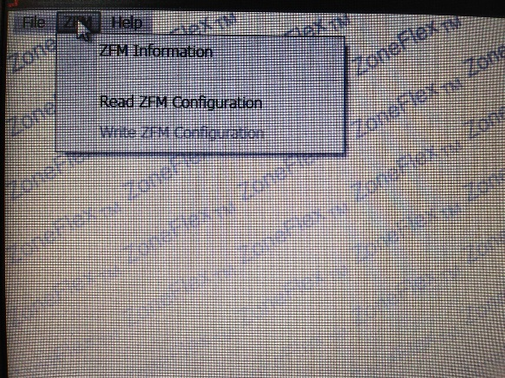

**4.0.2** Click on “Read ZFM Configuration”.

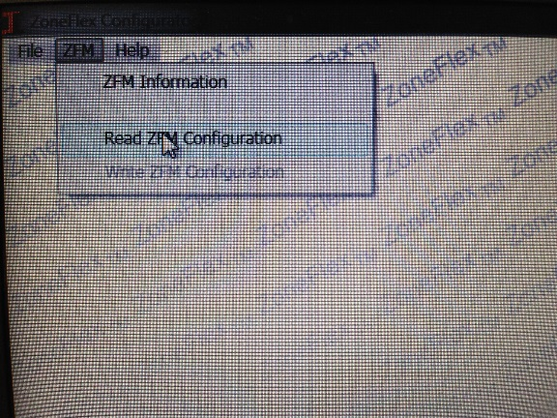

**4.0.3** Once the configuration is on the screen go to file on the top right corner and scroll down to “Save Configuration File”. Label the file with the appropriate conveyor number/name.

**5.0** To upload or export a configuration file to a ZFM, connect the ZoneFlex Manager to a laptop computer with the ZoneFlex Configurator program using a USB cable. Open up the ZoneFlex Configurator.

**5.0.1** Scroll to the top right corner and click on “Open Configuration File”, then double-click on the file with the appropriate conveyor number. Once the configuration opens, click “Send to ZFM” at the bottom of the screen. Allow the program a couple seconds to load.

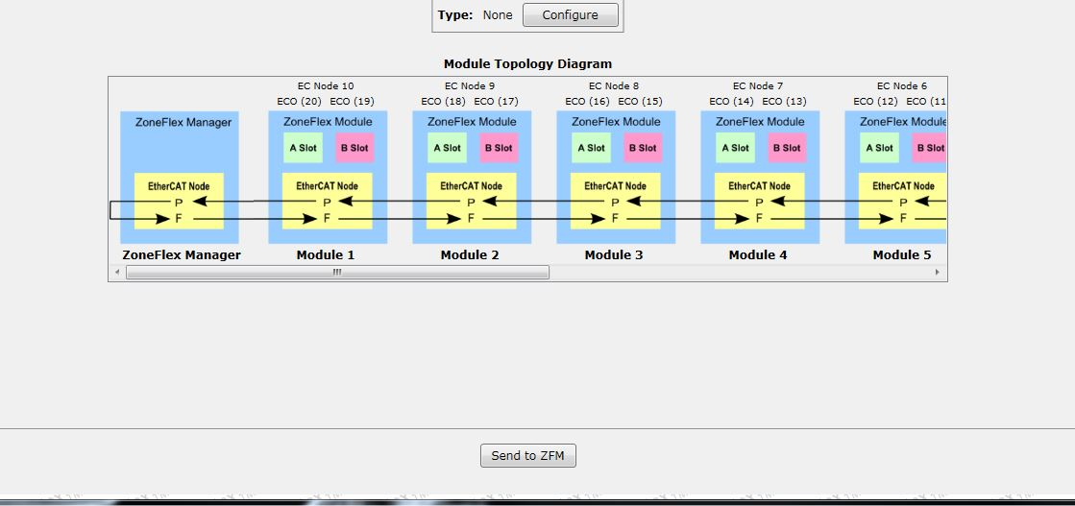

**5.0.2** Once the file is uploaded, check the nearest ZoneFlex Module for a typology error.

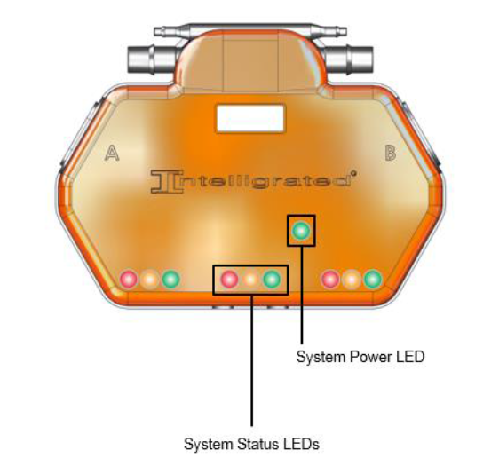

Flashing red light on a System Status LED means there is a typology error.

**5.0.3** If there is a typology error, the wrong file was uploaded. Find the proper file for that specific conveyor. If needed, call Intelligrated Customer Service.